SIMATS ENGINEERING (SAVEETHA SCHOOL OF ENGINEERING)
Department of Computer Science and Engineering

ASSESSMENT TOOL 1 – APPLICATION BASED QUESTIONS

Course Code: | CSA06 | Course Title: | Design and Analysis of Algorithms
CO Assessed: | CO1 – Precision (BL1, BL2, BL3) | Assessment: | Assessment Tool 1 – Application Based Questions
Weightage: | 40% of CIA | Total Marks: | 100 (2 Questions × 50 Marks)
CO1 Statement: | Determine algorithm efficiency using asymptotic notations and mathematical techniques including Master Theorem and substitution method. (BL1, BL2, BL3)
Student Name: | Lella Thannveer Reddy | Reg. No.: | 192524293
Section / Batch: | Slot-A | Date: | 16/07/2026

Instructions to Students
- Answer BOTH questions. Each question carries 50 Marks. Total: 100 Marks.
- Clearly show all steps in derivations and complexity analysis.
- Use proper asymptotic notation (Big-O, Big-Θ, Big-Ω) wherever required.
- Justify each step in recurrence solving using appropriate methods.
- Neat presentation and logical explanation are mandatory

Question Type | Focus Area | Questions | Marks
Application-Based Questions | Apply Master Theorem and asymptotic analysis to real-world scenarios | Q1 – Q2 | Q1 –50 Q2 –50
 | GRAND TOTAL: | 100 Marks

SECTION A – APPLICATION BASED QUESTIONS

Q1. Application: Weather Forecasting Simulation System
A weather simulation system uses two algorithms with complexities O(n log n) and O(n² log n). Analyze both algorithms using asymptotic notation and compare their growth rates. Explain how each algorithm performs as the dataset size increases. Determine which algorithm is more efficient for large-scale simulations. Justify your answer based on computational efficiency and scalability.
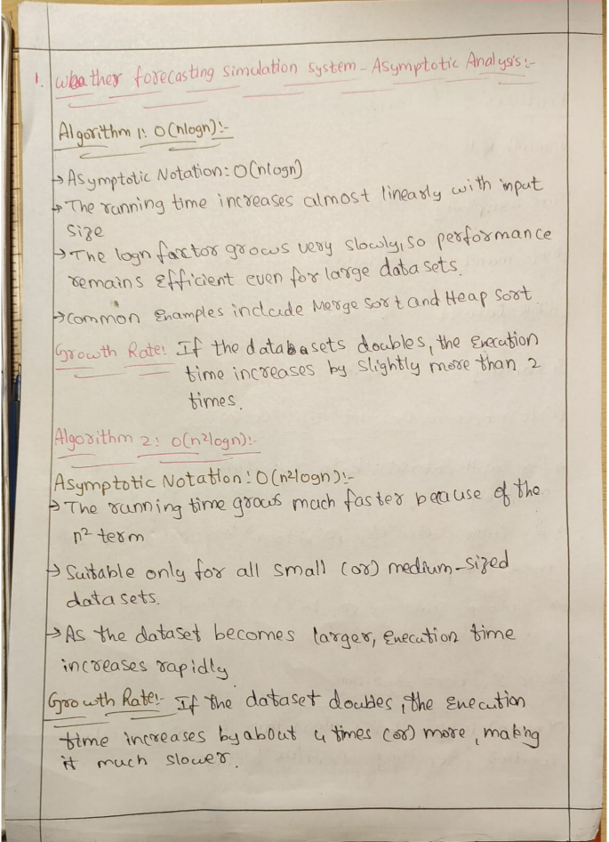
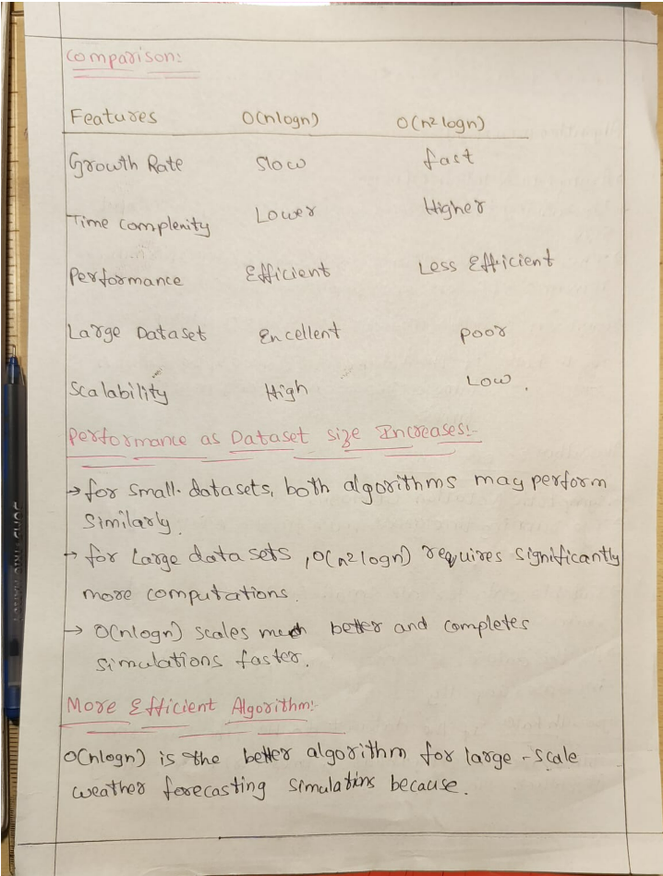
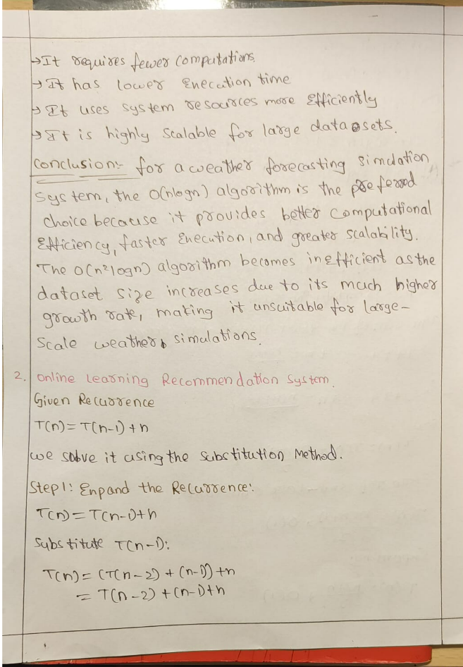

Q2. Application: Online Learning Recommendation System
An online learning platform processes user interaction data using the recurrence T(n) = T(n−1) + n. Apply the substitution method to expand the recurrence step-by-step and derive the final time complexity. Clearly show intermediate steps and simplify the expression. Analyze how the algorithm performs when the number of users grows rapidly. Interpret the efficiency using asymptotic notation and discuss whether the system is scalable for large educational platforms.

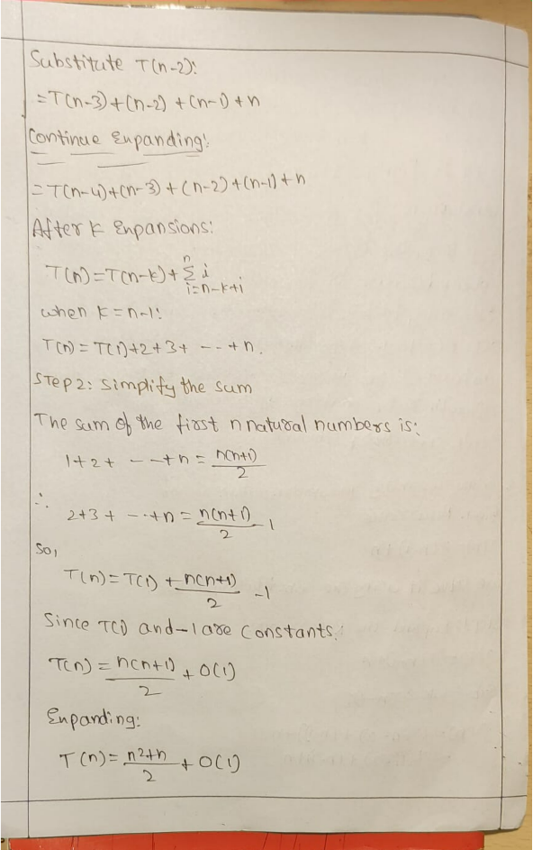
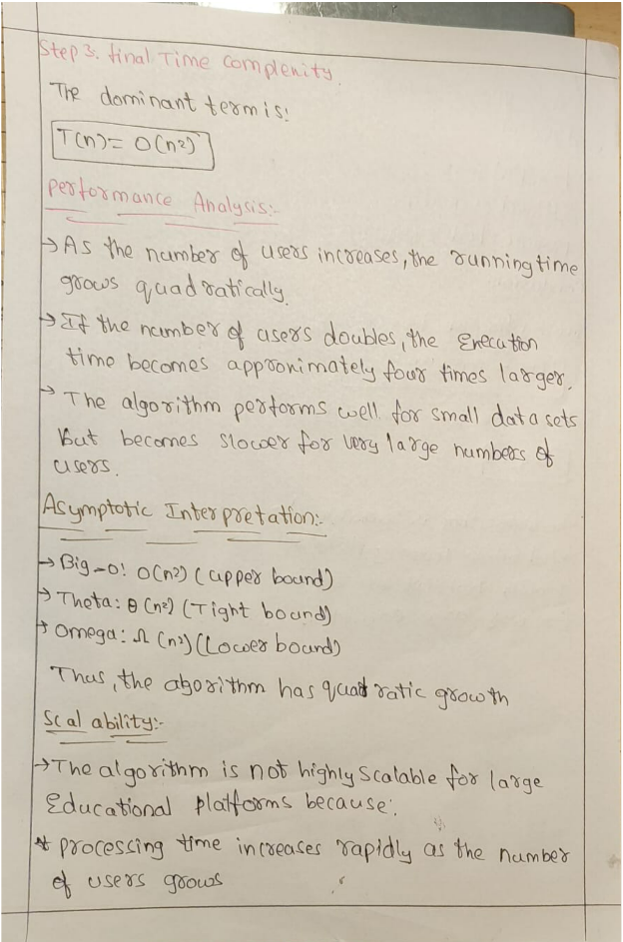

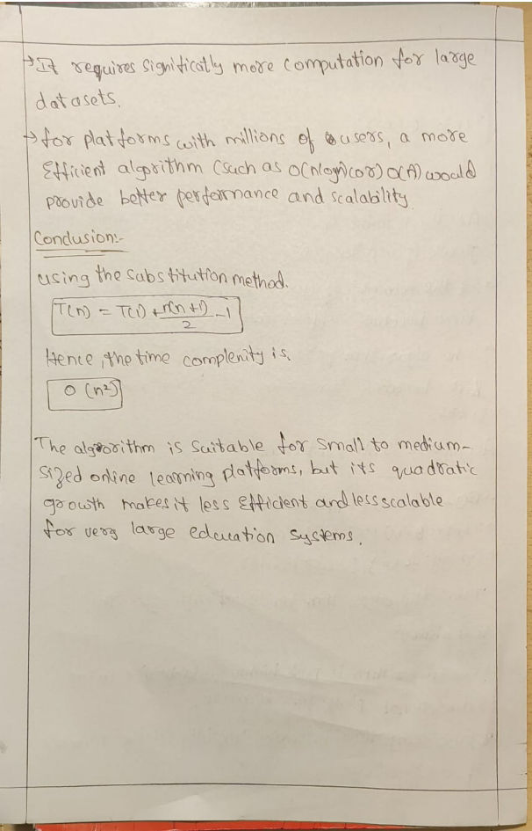

Code of Conduct
I Lella Thannveer Reddy/192524293 (Name / Reg No) certify that this submission is my original work and that I have adhered to the guidelines specified for this assessment. I understand that any violation of academic integrity rules will result in disciplinary action.
Signature of the Student: _Lella Thannveer Reddy_
RUBRICS FOR CALCULATION

Criteria | Wt. | Level 4 – Exemplary | Level 3 –  Proficient | Level 2 –  Developing | Level 1 –  Beginning
Understanding of Problem Context | 20% | Clearly understands the  problem and accurately  identifies all  requirements | Good understanding with minor gaps | Basic understanding; some requirements unclear | Poor understanding or misinterpretation of the problem
Application of  Concepts | 30% | Accurately applies appropriate concepts to solve complex problems | Applies relevant concepts correctly with minor errors | Applies basic concepts with limited accuracy | Fails to apply appropriate concepts
Problem-Solvi ng Approach | 20% | Logical, well-structured, and efficient approach | Mostly logical approach with minor gaps | Basic approach with some inconsistencies | Illogical or unclear approach
Accuracy of Solution | 20% | Completely correct solution with proper justification | Mostly correct with minor errors | Partially correct solution | Incorrect or incomplete solution
Clarity | 10% | Clear, well-organized, and properly explained solution | Understandable with minor clarity issues | Limited clarity and explanation | Poorly presented and difficult to understand
Marks Evaluation:
Question No. | Understanding of Problem  Context (20%) | Application of Concepts (30%) | Problem-So lving  Approach  (20%) | Accuracy  of  Solution  (20%) | Clarity (10%) | Total Marks
Q1
(50 Marks)
Q2
(50 Marks)
 |  |  |  | Overall Total (100)

Faculty In-charge | Course Coordinator | Head of Department
Signature: _______________ | Signature: _______________ | Signature: _______________
Date: ___________________ | Date: ___________________ | Date: ___________________

